How to edit the PublicKeyToken of a reference in a dll

Source: https://stackoverflow.com/questions/3889124/how-to-change-the-public-token-of-the-assembly

1. Open Visual Studio Developer tools. We will need the tools idasm.exe and ilasm.exe. If working with dll built from an old .NET framework versions like v2.0, find location on windows where the tools reside for the old framework. E.g. **C:\Windows\Microsoft.NET\Framework\v2.0.50727.** Note: For older .NET framework versions we just need the ilasm.exe from that old framework.
2. Run ildasm to disassemble dll.  
   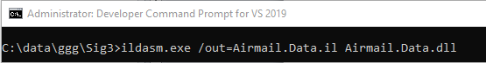

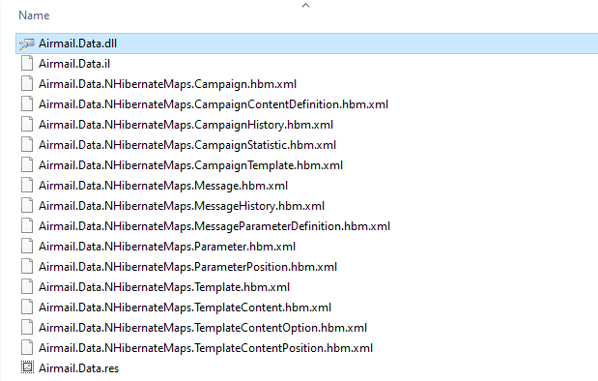

1. Edit Airmail.Data.il. Update the public key token and/or version of the reference.

In this example we updated the publickeytoken and ver for the AWSSDK reference.  
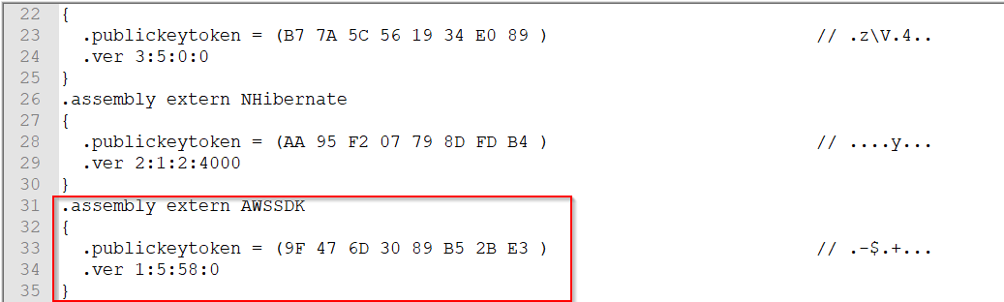

1. Run ilasm to re-assemble il to dll. In this case the dll was built on .NET framework v2. So we used ilasm tool from that framework folder.

